CDA Virtual Classroom
CDA Professional Portfolio
www.myECEclass.com
(360) 602-0960 * info@myececlass.com * PO Box 727, Burley, WA 98322-0727
Successful Solutions Professional Development LLC

The Professional Portfolio
Table of Contents
Benefits of Creating a Professional Portfolio 5
What is the Professional Portfolio? 6
Organizing Your Professional Portfolio 7
Suggested Materials for Organizing a Professional Portfolio 7
Suggested Materials for Organizing a Professional Portfolio 8
The Resource Collection 8
Guidelines for Writing CDA Reflective Competency Statements 10
Writing Competency Goal Statements 12
Guidelines for Writing Your Professional Philosophy Statement 13
My CDA Professional Portfolio Cover Sheet 15
Let's Review Tab A 17
CDA Education 17
Tab A – Education 17
Let's Review Tab B 18
Tab B - Family Questionnaires 18
Let's Review Tab C 19
Tab C - RC 1-2 Weekly Menu 20
Tab C - Competency Statement 1 21
Tab C - CS I a Sample Menu (from RC I-2) 23
Tab C - CS I b Room Environment 23
Tab C - CS I c Weekly Plan (from RC I-2) 24
Tab C - RC I-3 Weekly Lesson Plans 25
Let's Review Tab D 26
Tab D - RC II Learning Experiences 27
RC II-1 Science/Sensory 27
RC II-2 Language and Literacy 28
RC II-3 Creative Arts 28
RC II-4 Fine Motor (Indoor Activity) 29
RC II-5 Gross Motor (Outdoor Activity) 29
RC II-6 Self Concept 30
RC II-7 Emotional Skills/Regulation 30
RC II-8 Social Skills 31
RC II-9 Mathematics 31
(Optional) Music and Movement 32
Tab D - Competency Statement 2 33
Tab D - CS II a Learning Experiences (from RC II) 35
Tab D - CS II b Learning Experiences (from RC II) 35
Tab D - CS II c Learning Experiences (from RC II) 36
Tab D - CS II d Communication and Language Development 36
Let's Review Tab E 37
Tab E - RC III Developmentally Appropriate Books 38
Tab E - Competency Statement 3 42
Tab E - CS III a Developing Children’s Self-Concept 44
Tab E - CS III b Guiding Young Children’s Behavior 44
Let's Review Tab F 45
Tab F - RC IV-1 Family Resources Guide: Family Counseling 46
Tab F - RC IV-2 - Translation Service 46
Tab F - RC IV-3 Family Resources Guide: Children with Disabilities 47
Tab F - RC IV-4 Family Resources Guide: Child Development Resources 47
Tab F - Competency Statement 4 49
Tab F - CS IV a Communication with Families 50
Tab F – CS IV b Awareness of Children’s Home Life 51
Tab F - CS IV c Family Questionnaires Feedback 51
Let's Review Tab G 52
Tab G - RC V Record Keeping Forms 53
Tab G - RC V Accident Report Form 53
Tab G - RC V Emergency Form 53
Tab G - RC V Observation Form 53
Tab G - Competency Statement 5 54
Tab G - CS V a Observation Tool 56
Let's Review Tab H 57
Tab H - RC VI-1 Child Care Regulations 58
Tab H - RC VI-2 Early Childhood Associations 59
Tab H - RC VI-3 Reporting Child Abuse 60
Tab H - Competency Statement 6 61
Tab H - CS VI a Early Childhood Professional 63
Tab H - CS VI b Indicators of Professionalism 63
Let's Review Tab I 64
The Professional Philosophy Statement 64
Tab I - Philosophy Statement 64
Bring Your Professional Portfolio to your Verification Visit 66
CDA Credential Process 67
Step 4: Apply for the Credential 68
Remember to renew! 69

Benefits of Creating a Professional Portfolio
The Professional Portfolio is one of the main components that the CDA Council requires for a National CDA Credential. It is easy to get caught up in feeling that this is just another box to check along the way. However, there are many beneficial reasons to create a Portfolio documenting your experience and ideas as a professional or prospective educator.
Express Individuality
This is a great opportunity to express yourself as an educator and individual. You can include pictures, decorations, and other decals throughout the pages. Having fun with this is great, but also make sure you are not distracting away from your content by keeping it relevant and tasteful.
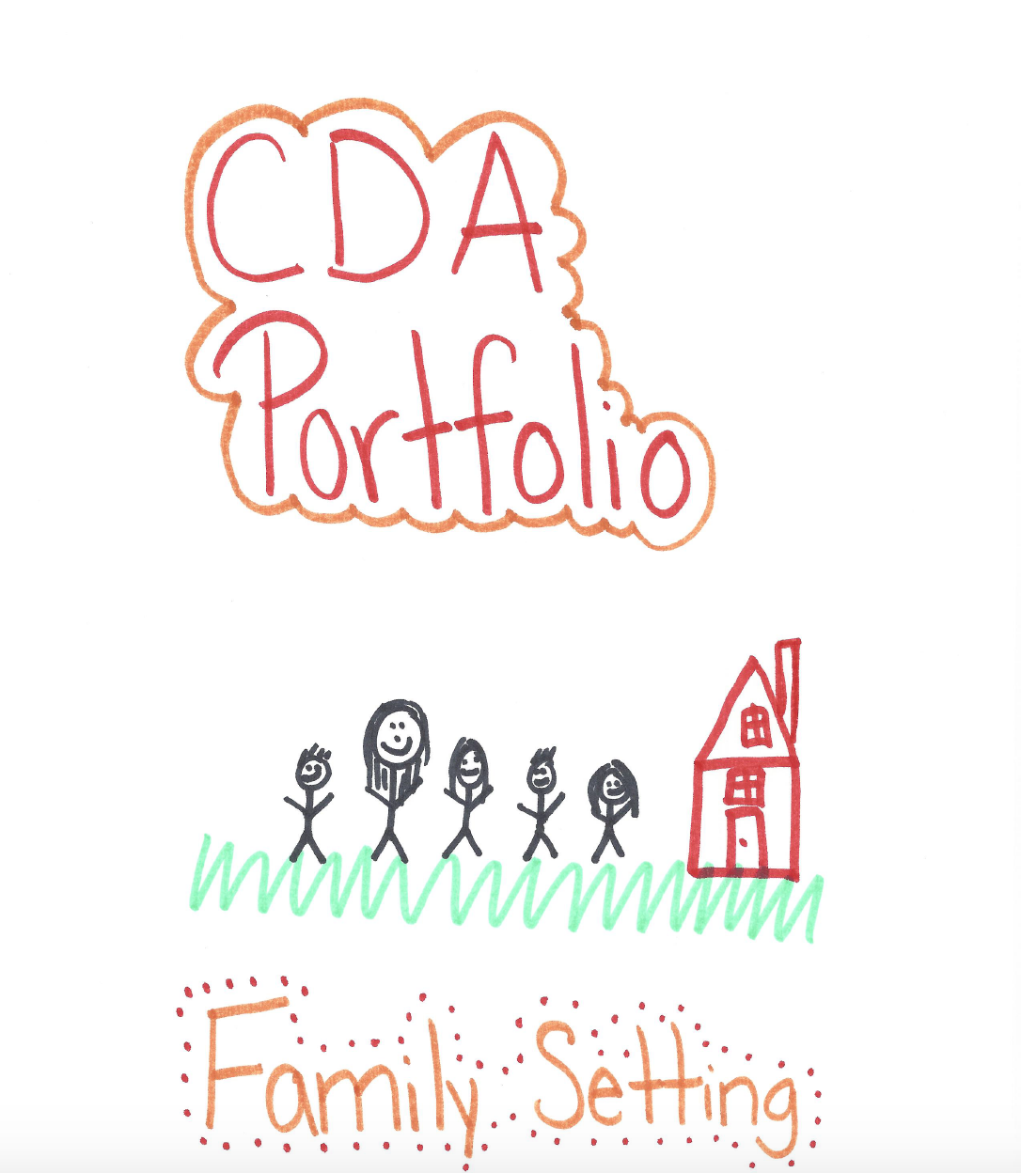

Self-Reflection

As you work through the Resource Assignments, take the time to explore the role that you play in the classroom. The assignments will include prompts to help you critically think about what you do and the way that your interactions with children influence their growth and development. Practicing self-reflection and accountability can help you to become an even better educator.

Receive Feedback

During the process of putting together your Professional Portfolio, you will be given the chance to receive feedback from the families that you serve. It is important to take their opinions into account and perhaps make some changes in your classroom or program planning.

Potential Employers

A perhaps overlooked benefit of having a Professional Portfolio is having it available to show to potential employers. This accumulation of your hard work and knowledge in the field could set you apart from other jobseekers.

Resource Compilation

Once you have your CDA Credential and you are working in a classroom, you don’t have to let your Professional Portfolio collect dust in a closet. There are other ways you could make use of it including:

- Compiling a list of the emergency numbers and resources that you collected to keep in your classroom
- Using the lesson plans as inspiration for classroom activities
- Looking back on it after a year in the field to see how your ideas or knowledge have changed

What is the Professional Portfolio?

The Professional Portfolio is a collection of materials that early childhood professionals use in their work with young children and their families. You will prepare a CDA Professional Portfolio as evidence of what you believe is valuable information to use in your work. This allows an opportunity for you to gain experience in locating resources and communicating skills and knowledge. The completed CDA Professional Portfolio is a tool that you will use during your career in early childhood education and can be used as a reference manual. It is your personal responsibility to organize your Professional Portfolio in accordance with these guidelines prior to applying for your CDA Credential.

Organizing Your Professional Portfolio

While there are no specific “rules” about how your Professional Portfolio should appear, it does need to be well organized and easy to use. The contents should be clearly labeled so that anyone looking at the Portfolio can quickly find each piece of information. It should also look professional – in other words, everything must be clean, nicely printed and legible. There should not be extra “clutter” to distract from the required information.

The most common ways to organize your Professional Portfolio are to use either a binder or a file box. Select the option that is easy for you to carry, store, and manage.

Suggested Materials for Organizing a Professional Portfolio

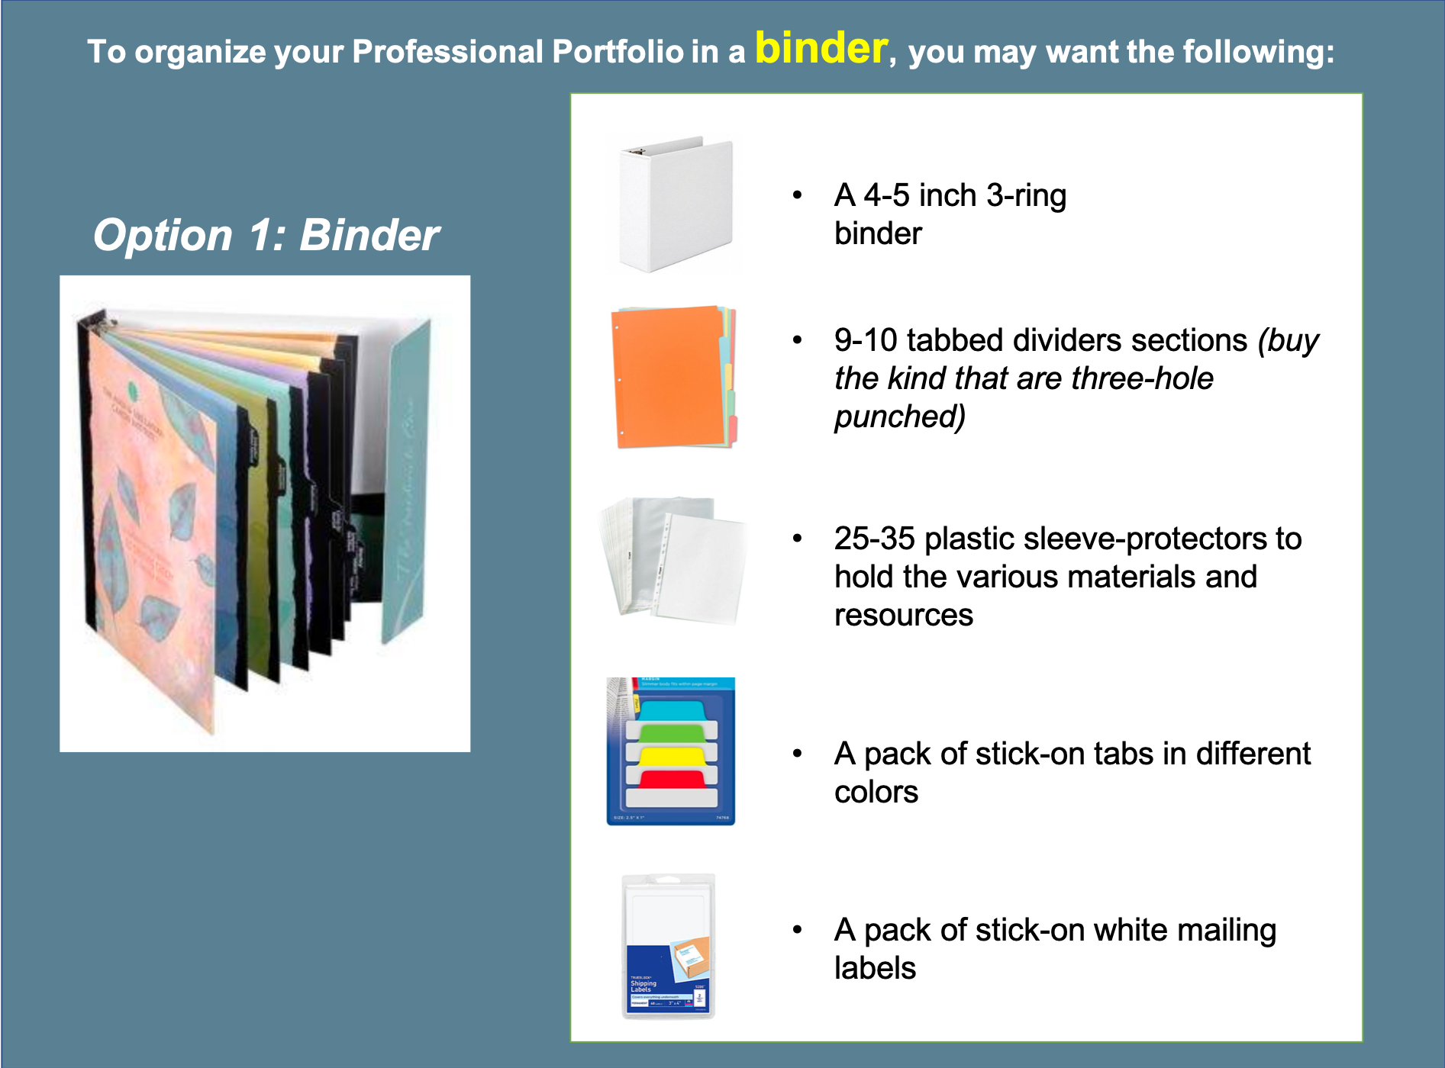

Suggested Materials for Organizing a Professional Portfolio

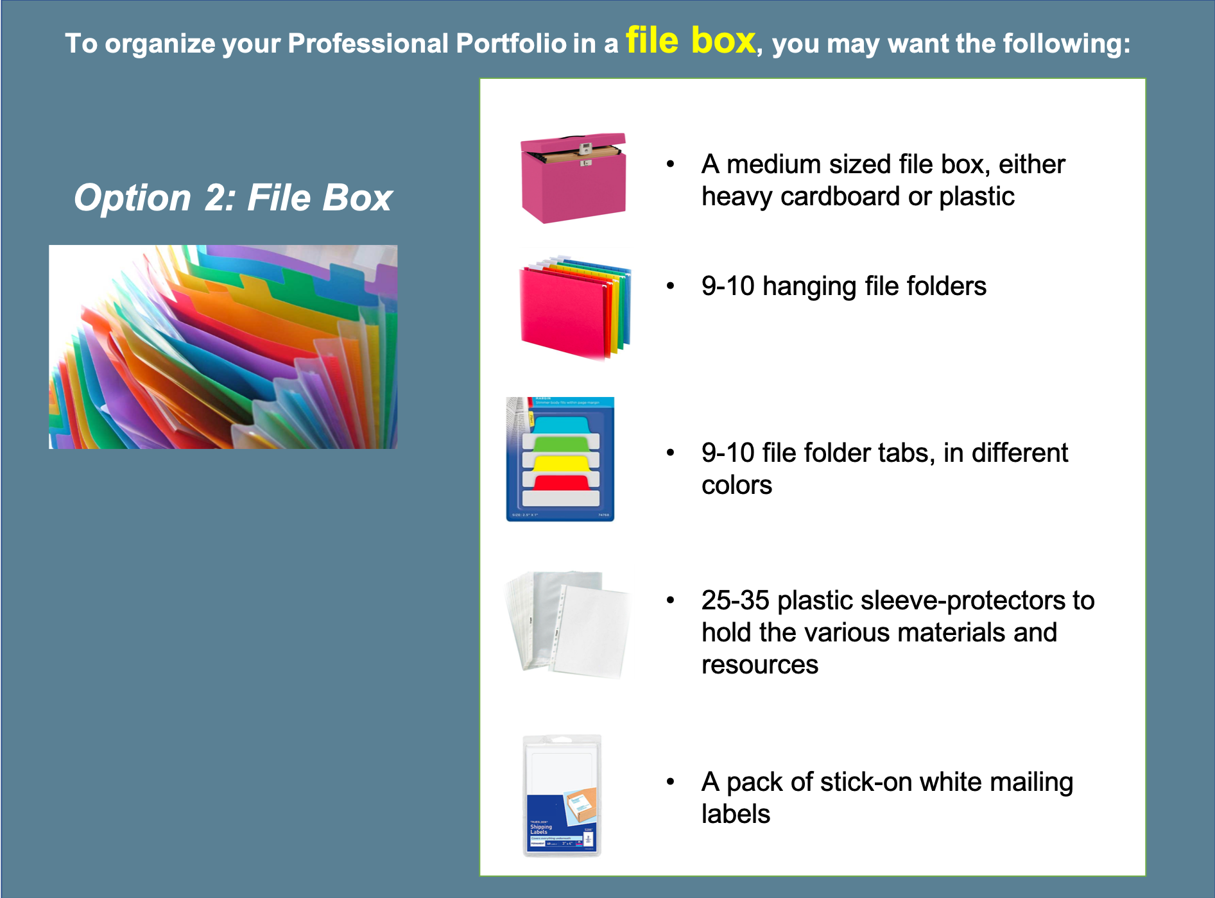

The Resource Collection

This part of the CDA Professional Portfolio consists of 10 specific items called the Resource Collection. These items must be organized by Competency Goal areas and numbered so that each item can be located easily during the Council Representative verification visit. Refer to pages 12-17 in the CDA Competency Standards Book.

- Materials inserted into page protectors must be visible without removing the material from the page protector. This means you should avoid inserting multiple pages behind each other within a single page protector. One exception to this rule is your Family Questionnaires because the PD Specialist will not read each of these, you may put them all in a single page protector.
- Clearly label each Resource Collection item so the PD Specialist can see that you have completed it.
- Use the checklist to make certain you have completed all the Resource Collection items.

Here is a list of the items that must be in your Professional Portfolio, in the order they should be placed. NOTE: All cover sheets are found in the back of the “CDA Competency Standards Book” booklet.

Cover Page: Your CDA Professional Portfolio cover sheet
Tab 1: CDA Education
- My CDA Education cover sheet
- All relevant training transcripts, certificates, and other official documentation such as college transcripts
Tab 2: Family Questionnaires
- Family Questionnaire cover sheet
- All completed and returned Family Questionnaires
Tab 3: Reflective Competency Statement 1
- Resource Collection Items RC I-1, RC I-2, and RC I-3
Tab 4: Reflective Competency Statement 2
- Resource Collection Items RC II-1 through RC II-9
Tab 5: Reflective Competency Statement 3 - Resource Collection Items RC III
Tab 6: Reflective Competency Statement 4
- Resource Collection Items RC IV-1 through RC IV-4
Tab 7: Reflective Competency Statement 5 - Resource Collection Items RC V
Tab 8: Reflective Competency Statement 6
- Resource Collection Items RC VI-1, RC VI-2, and RC VI-3
Tab 9: Professional Philosophy Statement

Attention: The depending on the version of the Competency Standard Book that you have, the checklist in your book may vary slightly in how the Tabs are labeled (A, B, C, etc.). You may label your binder tabs however you wish to, there is no "right way".

Guidelines for Writing CDA Reflective Competency Statements

You must write six (6) Statements of Competence based on the six Competency Goals. You begin writing each Statement of Competence with the following six (6) Competency Goal Statements:

- Goal 1: To establish and maintain a safe, healthy learning environment.
- Goal 2: To advance physical and intellectual competence.
- Goal 3: To support social and emotional development and to provide positive guidance.
- Goal 4: To establish positive and productive relationships with families.
- Goal 5: To ensure a well-run, purposeful program responsive to participant needs.
- Goal 6: To maintain a commitment to professionalism.

Your Reflective Competency Statements are a key part of your Professional Portfolio and you want to take the time to write them well. Your statements are intended to reflect your own teaching practices in each of the CDA Competency Standards areas.

Reflective Statements of Competence Guidelines
- Prepare 6 written reflections on your own teaching practices.
- You must write one Reflective Statement for each of the six CDA Competency Standards. Many of the statements require the use of specific resources from your Resource Collection as the focus of that written reflection.
- Each statement should be no more than 500 words in length.
- Spell-checked, written in full sentences, and grammatically correct.
- Each competency statement should be approximately 500 words long.

It’s helpful to divide each statement into the Functional Areas included in the Competency Standard and to write a brief paragraph for each of those Functional Areas. Your paragraphs should include information about “why” the Functional Area is important and 2-3 examples of “what” you do every day (your teaching practices) to provide that Functional Area for children. Many of the statements require that you focus on a specific resource you’ve collected for your Portfolio.

Below are examples of how you might write a paragraph for each Functional Area that describes the “why” and “what” of your work with children. Notice that these two paragraphs total only about 100 words yet clearly demonstrate knowledge of early childhood needs and good practices. Because you are limited in the number of words you can use for each statement, select your words carefully to be as descriptive as possible and to showcase your knowledge and skills.

“WHY” the Functional Area is important:
Example: “I know that maintaining a healthy environment in childcare is important because young children in childcare settings are more likely to be exposed to germs and their immune systems are not yet fully developed.”

“WHAT” you do every day to meet the Functional Area in your practice:
Example: “To make sure my environment is healthy for children, I practice safe hand washing by using liquid soap and paper towels, and make sure to wash my hands after changing diapers, before handling food, and after cleaning or coming in from outside. I teach the children to wash their hands for at least 20 seconds to get most germs off their hands. I have a daily schedule of sanitizing surfaces and toys to prevent the spread of germs.”

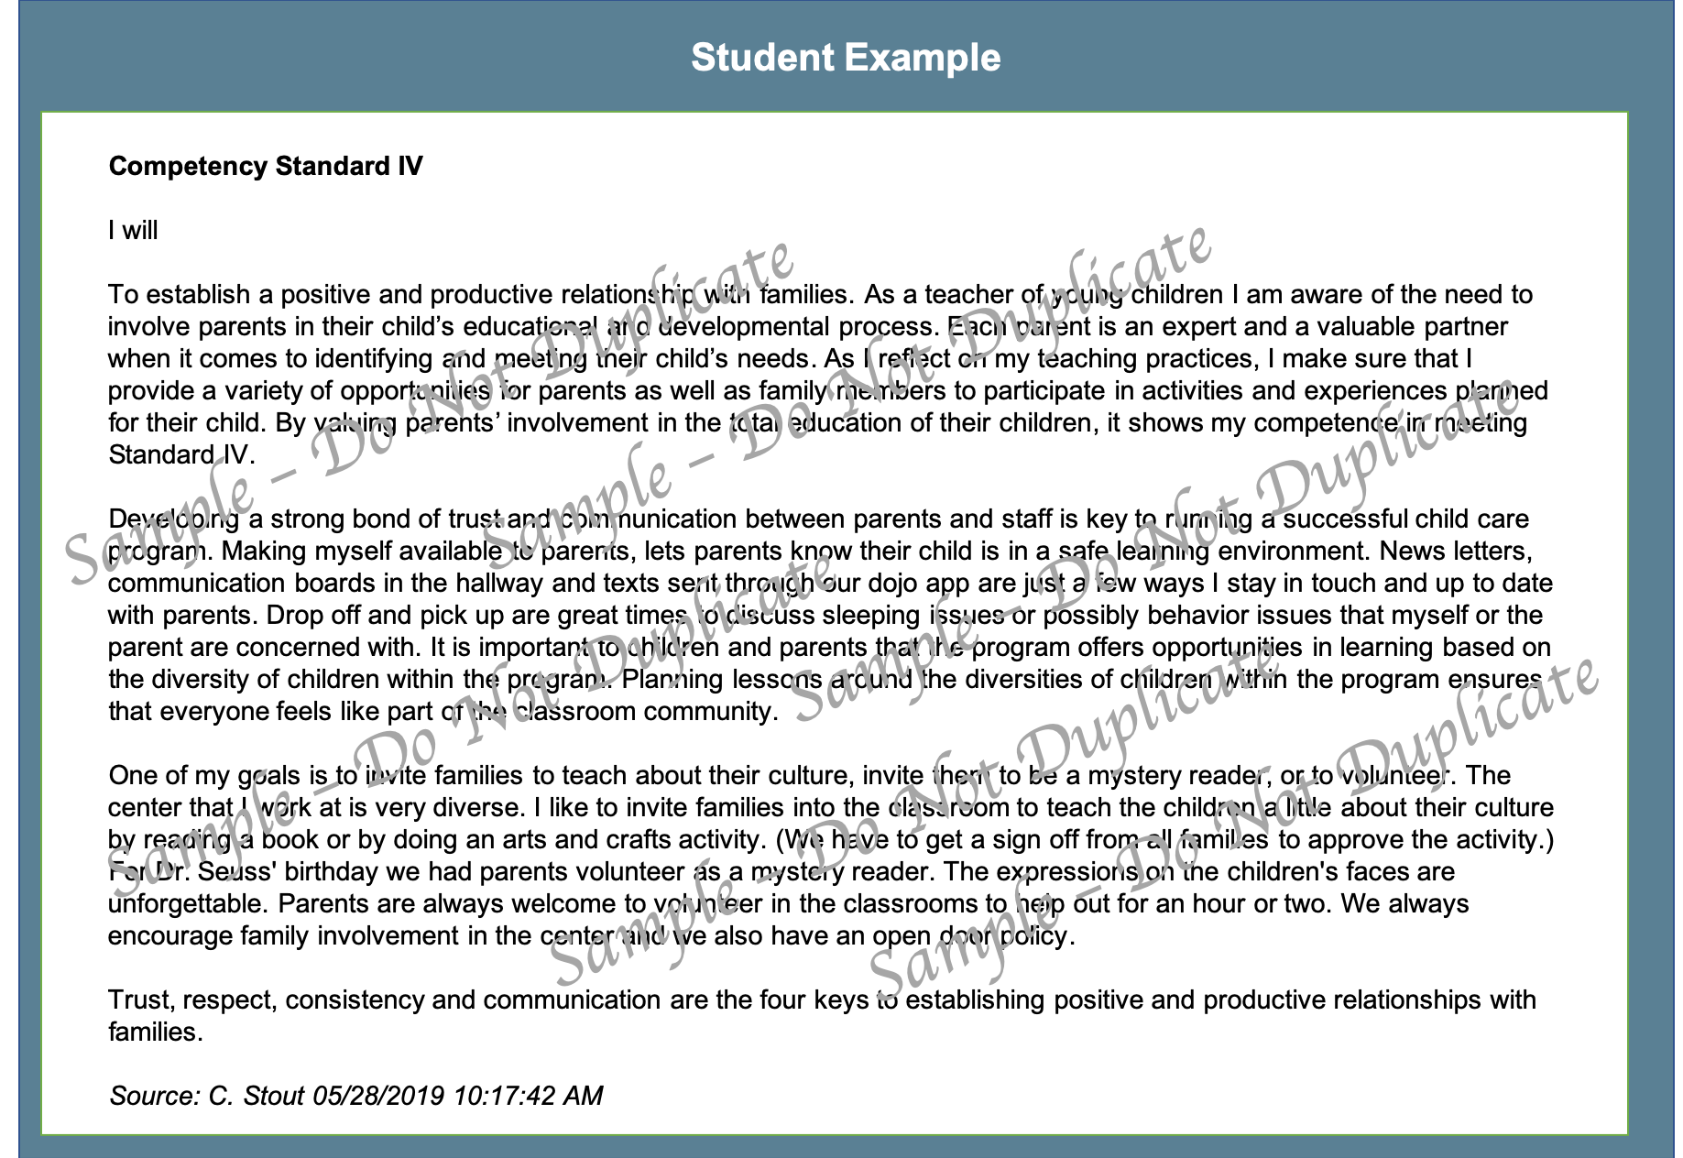

Be sure to use your own, original work. This is your opportunity to reflect on your understanding of the training topics and prove to the CDA Council why you deserve to receive the National CDA Credential.

Writing Competency Goal Statements

Following each competency statement, are the goal statements. Begin with an opening paragraph which includes:
- An overall introduction and concise summary explaining how you feel about this competency and its functional areas. The importance of it to you, the children, their parents, and the center. General ideas describing how your teaching practices meet these standards. This section should be about 100 – 200 words.
- Next, discuss each functional area in detail as it relates to your opening statement. Provide realistic and exact examples of actions that you will take to meet this functional area and competency goals for those within your care. This section will be about 50 – 150 words.

Many of the goal statements require the use of specific Resources from your Resource Collection as the focus of that written reflection. Write at least one paragraph on each of the reflections in the related Competency Statement.

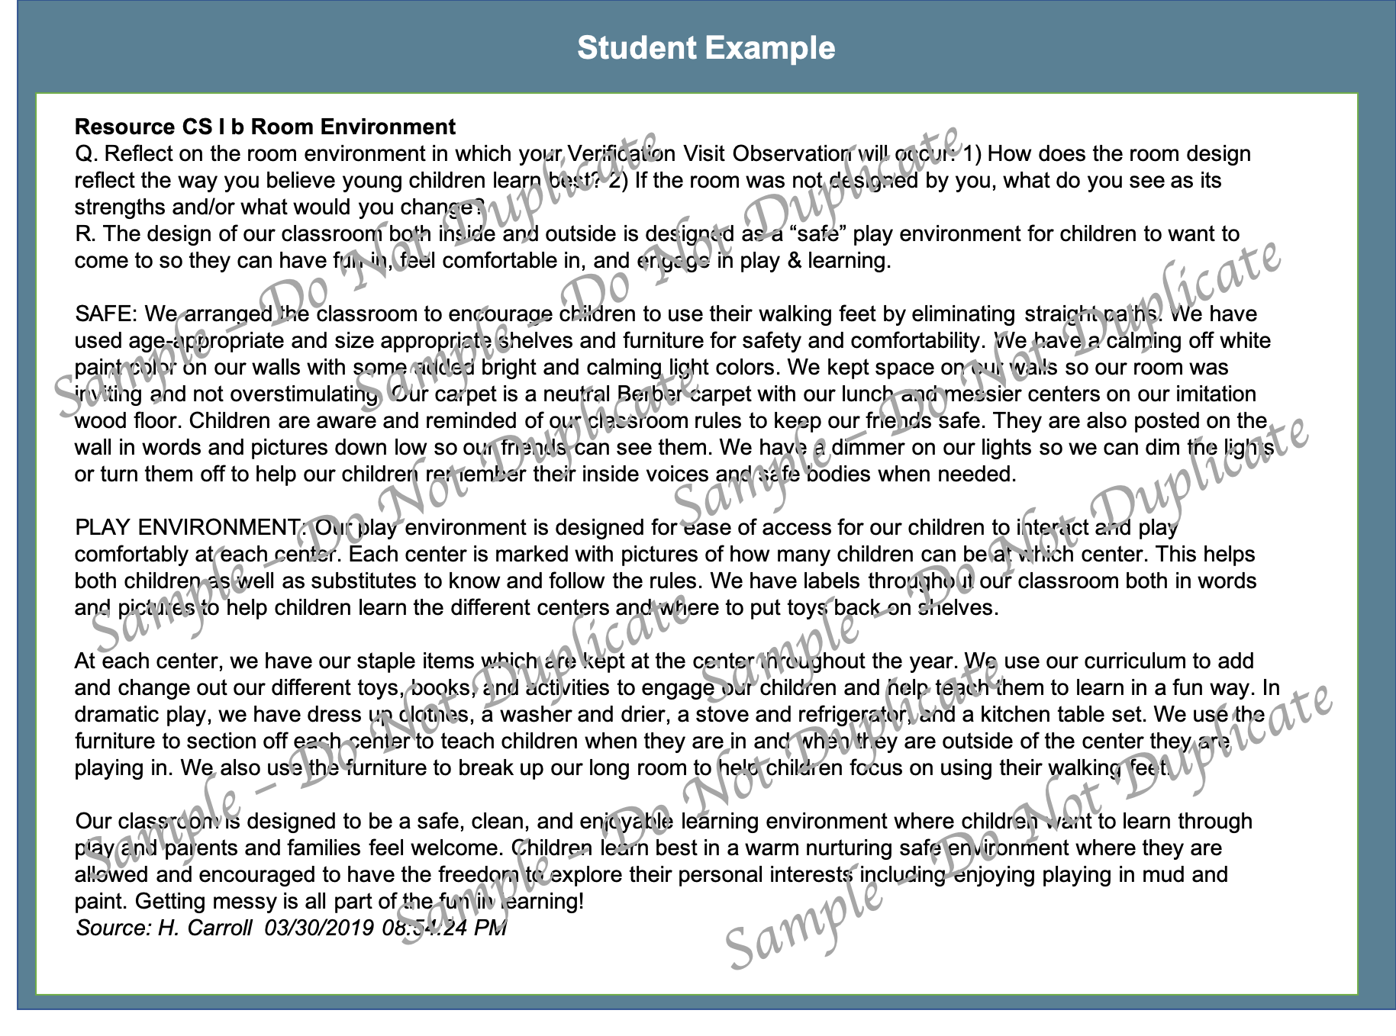

Guidelines for Writing Your Professional Philosophy Statement
The final piece of your CDA Professional Portfolio is your Professional Philosophy Statement. A Professional Philosophy Statement is a one to two-page document that describes in clear language your approach to teaching, the methods you use, and your expertise.
A philosophy statement is not a resume. Instead, it’s a description of:
- Your concept of teaching and learning
- A description of how you teach and/or provide care to young children
- Justification for why you teach or provide care in the way you do
Writing a Professional Philosophy Statement takes time and a lot of self-reflection. While there’s no right or wrong way to write a philosophy statement, your Philosophy Statement should align with your Reflective Competency Statements. The ideas and approaches to teaching that you describe should be similar in both sets of documents.
You may decide to write in paragraph form, create visuals, or use a question/answer format. However, here are some general “rules” to follow:
- Labeled with a heading and your name
- Clear and concise
- Spell-checked, written in full sentences, and grammatically correct
- Typed in 11-12-point font using Arial or Times New Roman
- No longer than 2 pages
Include teaching strategies and methods to help people “see” you in the classroom.
Include very specific examples of your teaching and caregiving strategies to help people visualize what you do every day with children and to give them a picture of the learning environment you’ve created.
Make it memorable and unique.
What sets you apart? What do you want the CDA Council to remember about you? How are you going to show the Council that you are intentional about supporting children’s development and learning, and that you are committed to your career?
“Own” your philosophy.
Avoid the use of declarative statements such as “The only way that children learn is...” You don’t want to appear that you are a know-it-all or that you are closed to new ideas. Instead, write about your experiences and your beliefs. When you “own” those statements, you appear more open to new and different ideas about teaching.
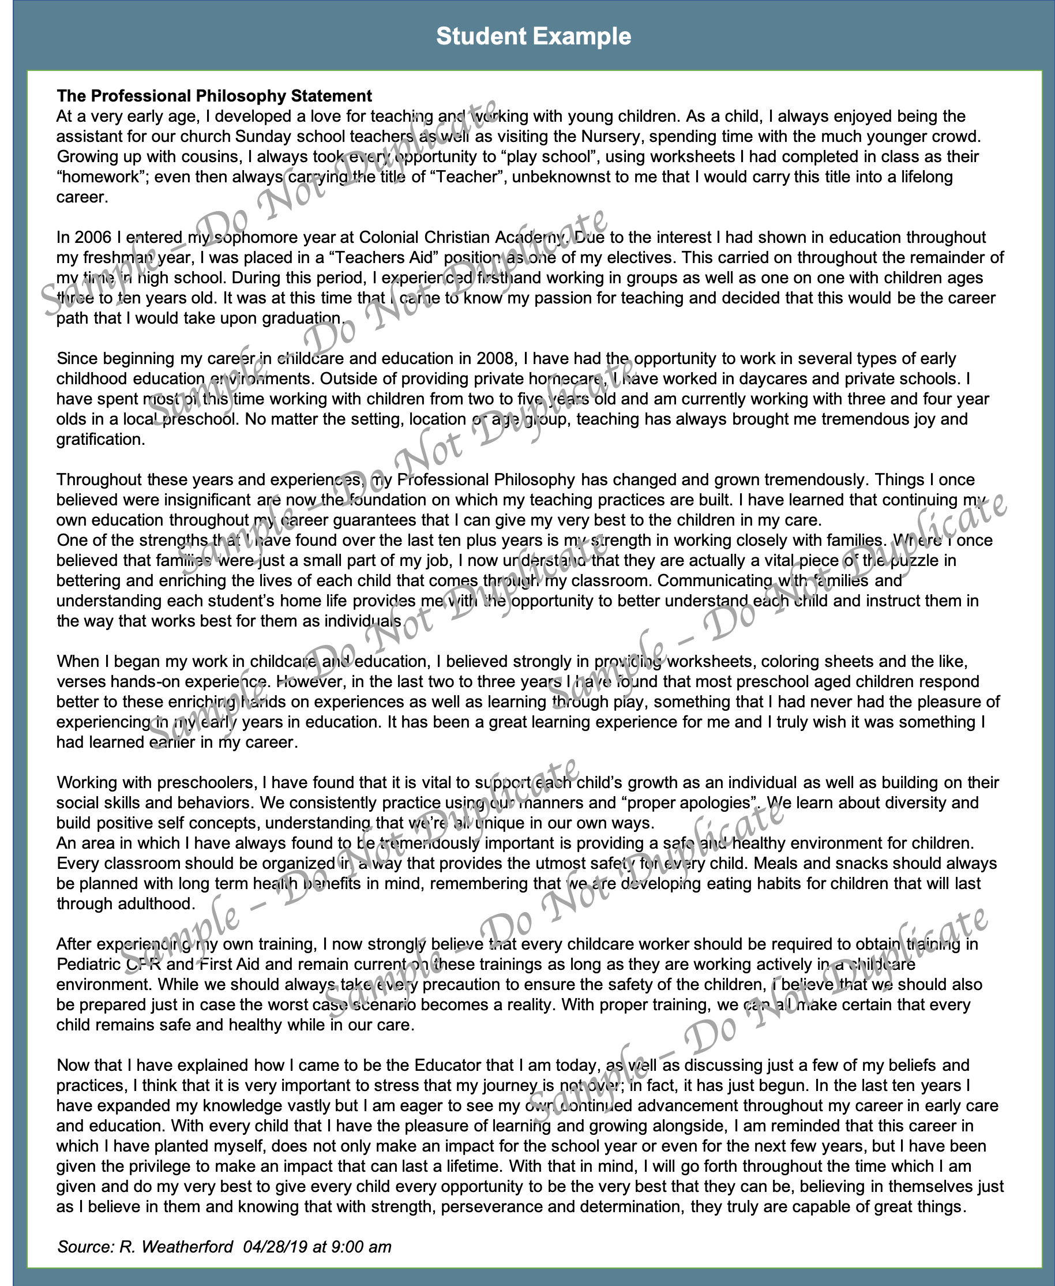

Be sure to use your own, original work. This is your opportunity to reflect on your understanding of the training topics and prove to the CDA Council why you deserve to receive the National CDA Credential.

My CDA Professional Portfolio Cover Sheet

The My CDA Professional Portfolio Cover Sheet can be found at the back of the CDA Competency Standards Book on page 131.

The cover sheet provides greater details on the specific order of portfolio components, use it as a checklist as you build your Portfolio to ensure that your completed Portfolio contains all the required contents.

The cover sheet should be placed at the front of your Professional Portfolio. The assignments in this course will be presented in the order of the checklist as provided on the My CDA Professional Portfolio Cover Sheet.

Attention: The depending on the version of the Competency Standard Book that you have, the checklist in your book may vary slightly in how the Tabs are labeled (A, B, C, etc.). You may label your binder tabs however you wish to, there is no "right way".

Use the following pages to prepare your Professional Portfolio.

Let's Review Tab A
CDA Education | My CDA Education Cover Sheet, and all relevant training transcripts, certificates, and other official documentation such as college transcripts to demonstrate that you have completed the required 120 hours of training.

Tab A – Education

The My CDA Education Cover Sheet can be found at the back of the CDA Competency Standards Book on page 132. Fill in this this form, and also include all relevant training transcripts, certificates, and other official documentation such as college transcripts to demonstrate that you have completed the required 120 hours of training.

Let's Review Tab B
Family Questionnaires | - Family Questionnaire cover sheet  - All completed and returned Family Questionnaires

Tab B - Family Questionnaires

Follow the instructions provided in the CDA Competency Standards Book (page 10) for the Family Questionnaires. A Family Questionnaire form is provided at the end of the CDA Competency Standards book for you to reproduce and distribute to families.
Add the following items to Tab B in your Professional Portfolio:
- Family Questionnaire cover sheet
- All completed and returned Family Questionnaires

Let's Review Tab C
RC I | - RC I-1 Include your valid and current certificates of completion or cards from a) any first aid course and b) an infant/child (pediatric) CPR course offered by a Nationally recognized training organization (such as American Red Cross or the American Heart Association). Online training is not acceptable.  - RC I-2 Provide a copy of one weekly menu for the age group which you are applying for the CDA Credential. In order to complete your related Reflective Competency Statement on this topic, the menu would ideally be one that you have participated in serving to and/or designing for children.  - RC I-3 Provide samples of your weekly lesson plans that include goals for children’s learning and development and brief descriptions of planned learning experiences. Indicate the age group for which the plan is intended. The lesson plans should be relevant to the age setting which you are applying for the CDA Credential (infant/toddler, preschool, or family setting). Complete a written explanation that explains how you will provide accommodations for children with special needs.
The Reflective Statement of Competence #1 | Competency Standard I: To establish and maintain a safe, healthy learning environment
CS I | CS I a Sample Menu (from RC I-2)  CS I b Room Environment  CS I c Weekly Plan (from RC I-3)

Attention: The depending on the version of the Competency Standard Book that you have, the checklist in your book may vary slightly in how the Tabs are labeled (A, B, C, etc.). You may label your binder tabs however you wish to, there is no "right way".

Tab C - RC 1-2 Weekly Menu

Directions: Fill in the one-week menu for the age group which you are applying for the CDA Credential. In order to complete your related Reflective Competency Statement on this topic, the menu would ideally be one that you have participated in serving to and/or designing for children
Indicate the age group (preschool) (infant or toddler) or (mixed-age family childcare) which the menu is intended.
- Be sure to save this assignment to print off and include in your Professional Portfolio under Tab C.

Weekly Menu
Age Group:
 | Monday | Tuesday | Wednesday | Thursday | Friday
Breakfast

Lunch
Snack

Tab C - Competency Statement 1
Directions: This Reflective Statement must relate directly to the Competency Standard I: To establish and maintain a safe, healthy learning environment.
The statement should be no more than 500 words in length.
Begin with a paragraph describing how your teaching practices meet the Competency Standard I: To establish and maintain a safe, healthy learning environment. (Note: alternatively, you may also choose to write one paragraph for each Functional Area, if this makes it easier to express your thoughts more clearly.)
- Be sure to save this assignment to print off and include in your Professional Portfolio under Tab C.

CDA Competency Standard I | Functional Areas |  | Definitions
I. To establish and maintain a safe, healthy learning environment | 1. Safe  2. Healthy  3. Learning Environment | 1. Candidate provides a safe environment and teaches children safe practices to prevent and reduce injuries.  2. Candidate provides an environment that promotes health and prevents illness and teaches children about good nutrition and practices that promote wellness.  3. Candidate organizes and uses relationships, the physical space, materials, daily schedule, and routines to create a secure, interesting, and enjoyable environment that promotes engagement, play, exploration, and learning of all children including children with disabilities and special needs.

Competency Standard I: To establish and maintain a safe, healthy learning environment
I will….

Tab C - CS I a Sample Menu (from RC I-2)

Reflect on the sample menu for Resource Collection I-2 that you participated in serving and/or designing: If you designed the menu, how does it reflect your commitment to children’s nutritional needs? If you served the menu but did not design it, what are its strengths and/or what would you change?

Tab C - CS I b Room Environment

Directions: This assignment requires you reflect on the room environment in which your Verification Visit Observation will occur.
- Be sure to save this assignment to print off and include in your Professional Portfolio under Tab C.

Tab C - CS I c Weekly Plan (from RC I-2)

Reflect on the weekly plan you included in your Resource Collection I-3. How does this plan reflect your philosophy of what young children need on a weekly basis? If the plan was not designed by you, what do you see as its strengths and/or what would you change?

Tab C - RC I-3 Weekly Lesson Plans

Directions: Provide a sample of a weekly plan that includes goals for children’s learning and development, a brief description of planned learning experiences, and also accommodations for children with special needs. Indicate the age group(s) for which the plan is intended.
- Be sure to save this assignment to print off and include in your Professional Portfolio under Tab C.
Weekly Theme: |  |  |  |  | Age Group:
Vocabulary Words: |  |  |  |  | Factual Statements:
Objective Goals: (Through participating in the experiences, the children may learn)
 | Monday | Tuesday |  | Wednesday |  |  | Thursday | Friday
Group Time
(songs, stories, games, etc.)
Outdoor Activities
(1 idea each day)
Small group activities  (1 activity in each. Curriculum area) | Language & Literacy | Music |  | Art |  |  | Science | Math
Special Needs Accommodations  (Hearing, seeing, speech, physical struggles, broken leg/arm, etc.) Choose 1 special need and 1 activity that you would adjust to accommodate the special need. |  |  |  | Special Need:
Dramatic Play |  |  | Blocks |  |  | Sensory Table (sand and water)
Fine Motor |  |  | Library Corner |  |  | Extra Activity

Let's Review Tab D
RC II | Describe nine learning experiences (activities), written in your own words, including one from each of the areas listed below. For each experience, indicate the age group (young infants, mobile infants, toddlers, 2s, 3s, 4s or 5s).  RC II-1 Science/Sensory  RC II-2 Language and Literacy  RC II-3 Creative Arts  RC II-4 Fine Motor (Indoor Activity)  RC II-5 Gross Motor (Outdoor Activity)  RC II-6 Self Concept  RC II-7 Emotional Skills/Regulation  RC II-8 Social Skills  RC II-9 Mathematics  Music and Movement
The Reflective Statement of Competence #2 | Competency Standard II: To advance physical and intellectual competence
CS II | CS II a Learning Experiences  CS II a Learning Experiences  CS II a Learning Experiences  CS II d Communication and Language Development

Attention: The depending on the version of the Competency Standard Book that you have, the checklist in your book may vary slightly in how the Tabs are labeled (A, B, C, etc.). You may label your binder tabs however you wish to, there is no "right way".

Tab D - RC II Learning Experiences

In your words, describe nine learning experiences (activities) that cover each of the following areas:

- RC II-1 Science/Sensory
- RC II-2 Language and Literacy
- RC II-3 Creative Arts
- RC II-4 Fine Motor (Indoor Activity)
- RC II-5 Gross Motor (Outdoor Activity)
- RC II-6 Self Concept
- RC II-7 Emotional Skills/Regulation
- RC II-8 Social Skills
- RC II-9 Mathematics
- Optional: Music and Movement

Directions:
- Include activities that YOU have planned and used in past lesson plans in your program.
- Indicate the age group (preschool setting: 3s, 4s, or 5s) OR (infant or toddler) and list the intended goals, materials and processes/teaching strategies.
- Discuss why it is developmentally appropriate for that age group.
- It is best to include a Visual/Sample/Picture of your activity and place it in a plastic sheet cover.
- Be sure to save this assignment to print off and include in your Professional Portfolio under Tab D.
For ideas, you may want to refer to the resource website: www.lessons4learners.com

RC II-1 Science/Sensory
Age Group:

Activity:

Supplies/Materials

Objective Goals: (Through participating in the experiences, the children may learn….)

Process:

How is this activity Developmentally Appropriate?

RC II-2 Language and Literacy
Age Group:

Activity:

Supplies/Materials

Objective Goals: (Through participating in the experiences, the children may learn…)

Process:

How is this activity Developmentally Appropriate?

RC II-3 Creative Arts
Age Group:

Activity:

Supplies/Materials

Objective Goals: (Through participating in the experiences, the children may learn…)

Process:

How is this activity Developmentally Appropriate?

RC II-4 Fine Motor (Indoor Activity)
Age Group:

Activity:

Supplies/Materials

Objective Goals: (Through participating in the experiences, the children may learn…)

Process:

How is this activity Developmentally Appropriate?

RC II-5 Gross Motor (Outdoor Activity)
Age Group:

Activity:

Supplies/Materials

Objective Goals: (Through participating in the experiences, the children may learn…)

Process:

How is this activity Developmentally Appropriate?

RC II-6 Self Concept
Age Group:

Activity:

Supplies/Materials

Objective Goals: (Through participating in the experiences, the children may learn…)

Process:

How is this activity Developmentally Appropriate?

RC II-7 Emotional Skills/Regulation
Age Group:

Activity:

Supplies/Materials

Objective Goals: (Through participating in the experiences, the children may learn…)

Process:

How is this activity Developmentally Appropriate?

RC II-8 Social Skills
Age Group:

Activity:

Supplies/Materials

Objective Goals: (Through participating in the experiences, the children may learn…)

Process:

How is this activity Developmentally Appropriate?

RC II-9 Mathematics
Age Group:

Activity:

Supplies/Materials

Objective Goals: (Through participating in the experiences, the children may learn…)

Process:

How is this activity Developmentally Appropriate?

(Optional) Music and Movement
Age Group:

Activity:

Supplies/Materials

Objective Goals: (Through participating in the experiences, the children may learn…)

Process:

How is this activity Developmentally Appropriate?

Tab D - Competency Statement 2

Directions: This Reflective Statement must relate directly to the Competency Standard II: To advance physical and intellectual competence.

The statement should be no more than 500 words in length.
Begin with a paragraph describing how your teaching practices meet the Competency Standard II: To advance physical and intellectual competence. (Note: alternatively, you may also choose to write one paragraph for each Functional Area, if this makes it easier to express your thoughts more clearly.)
- Be sure to save this assignment to print off and include in your Professional Portfolio under Tab D.

CDA Competency Standard II | Functional Areas |  | Definitions
II. To advance physical and intellectual competence | 4. Physical  5. Cognitive  6.Communication  7. Creative | 4. Candidate uses a variety of developmentally appropriate equipment, learning experiences, and teaching strategies to promote the physical development (fine and gross motor) of all children.  5. Candidate uses a variety of developmentally appropriate learning experiences and teaching strategies to promote curiosity, reasoning, and problem solving, and to lay the foundation for all later learning. Candidate implements curriculum that promotes children’s learning of important mathematics, science, technology, social studies, and other content goals.  6. Candidate uses a variety of developmentally appropriate learning experiences and teaching strategies to promote children’s language and early literacy learning and help them communicate their thoughts and feelings verbally and nonverbally. Candidate helps dual-language learners make progress in understanding and speaking both English and their home language.  7. Candidate uses a variety of developmentally appropriate learning experiences and teaching strategies for children to explore music, movement, and the visual arts, and to develop and express their creative abilities.

- Competency Standard II: To advance physical and intellectual competence
I will….

Tab D - CS II a Learning Experiences (from RC II)

Directions: Pick one of the nine learning experiences you chose for your Resource Collection II. How does this experience reflect your personal philosophy of how you support young children’s physical development?
- Be sure to save this assignment to print off and include in your Professional Portfolio under Tab D.

Tab D - CS II b Learning Experiences (from RC II)

Directions: Pick another one of the nine learning experiences you chose for your Resource Collection II. How does this experience reflect your personal philosophy of how you support young children’s cognitive development?

Tab D - CS II c Learning Experiences (from RC II)

Directions: Pick a third learning experience you chose for your Resource Collection II. How does this experience reflect your personal philosophy of how you support young children’s creative development?

Tab D - CS II d Communication and Language Development

Directions: Describe ways to promote the communication and language development among all children including dual language learners.

Let's Review Tab E
RC III | A bibliography that includes the titles, authors, publishers, copyright dates and short summaries of ten developmentally appropriate children's books that you have used with young children. Each book should support a different topic related to children's lives and challenges.
The Reflective Statement of Competence #3 | Competency Standard III: To support social and emotional development and to provide positive guidance
CS III | CS III a Developing Children's Self-Concept  CS III b Guiding Young Children's Behavior

Attention: The depending on the version of the Competency Standard Book that you have, the checklist in your book may vary slightly in how the Tabs are labeled (A, B, C, etc.). You may label your binder tabs however you wish to, there is no "right way".

Tab E - RC III Developmentally Appropriate Books

Directions: Create a bibliography that includes the titles, authors, publishers, copyright dates, and short summaries of ten (10) developmentally appropriate children’s books that YOU have used with young children. Each book should support a different topic related to children’s lives and challenges.
Subjects you might consider addressing include: Cultural and linguistic group identity; gender identity; children with special needs; separation, divorce, remarriage, or family structures; phases of the cycle of life from human reproduction to death; other topics that reflect the children and families with whom you work.
- Be sure to save this assignment to print off and include in your Professional Portfolio under Tab E.

#1 Title of the Book | Author | Publisher | Copyright date
Short Summary of the age-appropriate children’s book:

What area of a child’s life or challenges does this book support and explain how:

#2 Title of the Book | Author | Publisher | Copyright date
Short Summary of the age-appropriate children’s book:

What area of a child’s life or challenges does this book support and explain how:

#3 Title of the Book | Author | Publisher | Copyright date
Short Summary of the age-appropriate children’s book:

What area of a child’s life or challenges does this book support and explain how:

#4 Title of the Book | Author | Publisher | Copyright date
Short Summary of the age-appropriate children’s book:

What area of a child’s life or challenges does this book support and explain how:

#5 Title of the Book | Author | Publisher | Copyright date
Short Summary of the age-appropriate children’s book:

What area of a child’s life or challenges does this book support and explain how:

#6 Title of the Book | Author | Publisher | Copyright date
Short Summary of the age-appropriate children’s book:

What area of a child’s life or challenges does this book support and explain how:

#7 Title of the Book | Author | Publisher | Copyright date
Short Summary of the age-appropriate children’s book:

What area of a child’s life or challenges does this book support and explain how:

#8 Title of the Book | Author | Publisher | Copyright date
Short Summary of the age-appropriate children’s book:

What area of a child’s life or challenges does this book support and explain how:

#9 Title of the Book | Author | Publisher | Copyright date
Short Summary of the age-appropriate children’s book:

What area of a child’s life or challenges does this book support and explain how:

#10 Title of the Book | Author | Publisher | Copyright date
Short Summary of the age-appropriate children’s book:

What area of a child’s life or challenges does this book support and explain how:

Tab E - Competency Statement 3

Directions: This Reflective Statement must relate directly to the Competency Standard III: Supporting children's social and emotional development.

The statement should be no more than 500 words in length.

Begin with a paragraph describing how your teaching practices meet the Competency Standard III: Supporting children's social and emotional development. (Note: alternatively, you may also choose to write one paragraph for each Functional Area, if this makes it easier to express your thoughts more clearly.)
- Be sure to save this assignment to print off and include in your Professional Portfolio under Tab E.

Competency Standard III: To support social and emotional development and to provide positive guidance
CDA Competency Standard III | Functional Areas |  | Definitions
III. To support social and emotional development and  to provide positive guidance | 8. Self  9. Social  10. Guidance | 8. Candidate develops a warm, positive, supportive, and responsive relationship with each child, and helps each child learn about and take pride in their own individual and cultural identity.  9. Candidate helps each child function effectively in the group, learn to express feelings, acquire social skills, and make friends, and promotes mutual respect among children and adults.  10. Candidate provides a supportive environment and uses effective strategies to promote children’s self-regulation and support acceptable behaviors, and effectively intervenes for children with persistent challenging behaviors.

I will….

Tab E - CS III a Developing Children’s Self-Concept

Directions: In your own words, describe some of the ways you support the development of children’s positive self-concepts and growing social/emotional skills.
- Be sure to save this assignment to print off and include in your Professional Portfolio under Tab E.

Tab E - CS III b Guiding Young Children’s Behavior

Directions: In your own words, reflect on your personal philosophy of guiding young children’s POSITIVE behaviors. How is your professional philosophy similar or different from how you were guided as a child? How do you constructively deal with young children’s challenging behaviors?
- Be sure to save this assignment to print off and include in your Professional Portfolio under Tab E.

Let's Review Tab F
RC IV | Create a Family Resources Guide that you might choose to share with the families you serve. The guide should include helpful working information you think they might need. At a minimum, you must include the following required items. Add any other items that children within your care might also need.  RC IV-1 The name and contact information of a local agency that provides family counseling.  RC IV-2 Find out contact information of a translation service for families whose home language is other than English as well as a service that provides American Sign Language translation.  RC IV-3 Obtain contact information for at least two agencies in the community that provide resources and services for children with disabilities.  RC IV-4 Provide a list of 3 or more websites, and brief descriptions of each, that provide current information to help families understand how young children develop and learn. Include one current article from each website. (See page 14 of the CDA Competency Standards Book.)
The Reflective Statement of Competence #4 | Competency Standard IV: To establish positive and productive relationships with families
CS IV | CS IV a Communication with Families  CS IV b Awareness of Children's Home Life  CS IV c Family Questionnaires Feedback

Attention: The depending on the version of the Competency Standard Book that you have, the checklist in your book may vary slightly in how the Tabs are labeled (A, B, C, etc.). You may label your binder tabs however you wish to, there is no "right way".

Tab F - RC IV-1 Family Resources Guide: Family Counseling
- Be sure to save this assignment to print off and include in your Professional Portfolio under Tab F.

Directions: Provide the contact information (agency name, phone number, website, address, etc.) of a local agency in the community where you work that provides family counseling.

Tab F - RC IV-2 - Translation Service

Directions: Find out contact information (agency name, phone number, website, address, etc.) of a translation service for families whose home language is other than English as well as a service that provides American Sign Language translation.

Translation Service where the home language is other than English: | Service for American Sign Language Translation:

Tab F - RC IV-3 Family Resources Guide: Children with Disabilities

Directions: Obtain contact information (agency name, phone number, website, address, etc.) for at least two agencies in the community that provide resources and services for children with disabilities (in most communities, the local school district provides these services).

Tab F - RC IV-4 Family Resources Guide: Child Development Resources

Directions:
- Provide a list of 3 or more websites, and brief descriptions of each website, that provide current information to help families understand how young children develop and learn. Include one current article from each website.
- Web sites must contain articles that help families understand the development and learning of the age group which corresponds with the setting that you are applying for the CDA Credential (preschool setting: 3s, 4s, or 5s) OR (infant or toddler).
- At least one article must relate to child guidance.

Source #1 | Source #2
Source #3 | Source #4 (Optional)

Print off and place your THREE Resource IV-4 articles on how young children develop and learn In your Professional Portfolio behind this page.
Remember that one of the three articles must relate to child guidance.

NEXT, place your THREE Resource IV-4 articles on how young children develop and learn.

Tab F - Competency Statement 4

Directions: This Reflective Statement must relate directly to the Competency Standard IV: To establish positive and productive relationships with families.
The statement should be no more than 500 words in length.
Begin with a paragraph describing how your teaching practices meet the Competency Standard IV: To establish positive and productive relationships with families. (Note: alternatively, you may also choose to write one paragraph for each Functional Area, if this makes it easier to express your thoughts more clearly.)
- Be sure to save this assignment to print off and include in your Professional Portfolio under Tab F.

Competency Standard IV: To establish positive and productive relationships with families
CDA Competency Standard IV | Functional Areas |  | Definitions
IV. To establish positive and productive relationships with families. | 11. Families | 11. Candidate establishes a positive, responsive, and cooperative relationship with each child’s family, engages in two-way communication with families, encourages their involvement in the program, and supports the child’s relationship with his or her family.

I will….

Tab F - CS IV a Communication with Families
- Be sure to save this assignment to print off and include in your Professional Portfolio under Tab F.

Directions: In your words, describe the following: How do you ensure that families are kept aware of what’s happening in their child’s daily/weekly life in your program?

Tab F – CS IV b Awareness of Children’s Home Life

Directions: In your words, describe the following: How do you ensure that you are aware of what’s happening in each child’s home life? How does that awareness direct your teaching practices? Include activities you have planned and used in past lesson plans in your program.

Tab F - CS IV c Family Questionnaires Feedback

Directions: Reflect on the feedback you received in the Family Questionnaires you collected. Explain how the responses surprised you, confirmed your own reflections about yourself and/or gave you a new goal for professional growth.

Let's Review Tab G
RC V | Provide three samples of record keeping forms that you use or have used. Include an accident report form, an emergency form, and a completed tool or form that you have used to observe for and document a child’s developmental/learning progress (DO NOT INCLUDE CHILD’S NAME).
The Reflective Statement of Competence #5 | Competency Standard V: To ensure a well-run, purposeful program that is responsive to participant needs
CS V | CS V a Observation Tool (from RC V)

Attention: The depending on the version of the Competency Standard Book that you have, the checklist in your book may vary slightly in how the Tabs are labeled (A, B, C, etc.). You may label your binder tabs however you wish to, there is no "right way".

Tab G - RC V Record Keeping Forms
- Be sure to save this assignment to print off and include in your Professional Portfolio under Tab G.
- Provide three (3) samples of record keeping forms that you use or have used. Include the following:
  - an accident report form
  - an emergency form
  - a completed tool or form that you have used to observe for and document a child’s developmental/learning progress (DO NOT INCLUDE CHILD’S NAME)
- These three forms must be included in your Professional Portfolio Tab G.

Tab G - RC V Accident Report Form

#1 For this resource, you will include a blank Accident Report Form that you use or have used in your program.

Tab G - RC V Emergency Form

#2 For this resource, you will include a blank Emergency Form. Make sure that you provide record keeping forms that you use or have used in your program.

Tab G - RC V Observation Form
#3 For this resource, you will include a completed tool or form that you have used to observe for and document a child’s developmental/learning progress (observation form). DO NOT INCLUDE THE CHILD’S NAME. Make sure that you provide record keeping forms that you use or have used in your program.

Tab G - Competency Statement 5

Directions: This Reflective Statement must relate directly to the Competency Standard V: To ensure a well-run, purposeful program that is responsive to participant need.

The statement should be no more than 500 words in length.

Begin with a paragraph describing how your teaching practices meet the Competency Standard V: To ensure a well-run, purposeful program that is responsive to participant needs. (Note: alternatively, you may also choose to write one paragraph for each Functional Area, if this makes it easier to express your thoughts more clearly.)
- Be sure to save this assignment to print off and include in your Professional Portfolio under Tab G.

Competency Standard V: To ensure a well-run, purposeful program that is responsive to participant needs
CDA Competency Standard V | Functional Areas |  | Definitions
V. To ensure a well-run, purposeful program responsive to participant needs | 12. Program Management | 12. Candidate is a manager who uses observation, documentation, and planning to support children’s development and learning and to ensure effective operation of the classroom or group. The Candidate is a competent organizer, planner, record keeper, communicator, and a cooperative co-worker.

I will….

Tab G - CS V a Observation Tool

Directions: Describe how you used the observation tool/form from Resource Collection V.

Importance of Observation and Documentation
Directions: Explain why observation and documentation forms are an important part of program management.

Accurate Observations
Directions: How do you ensure that you are accurately and objectively observing and tracking each child’s developmental and learning progress?

Let's Review Tab H
RC VI | RC VI-1 Provide the contact information (agency name, website, phone number, address, etc.) of your state’s agency that is responsible for the regulation of childcare centers and family childcare homes. These regulations are available at the website of the National Database of Child Care Licensing Regulations: https://childcareta.acf.hhs.gov/licensing  RC VI-2 List two or three early childhood associations (national, regional, state, or local) and include website addresses, and describe the professional resources and membership opportunities they each offer.  RC VI-3 Provide summaries of the legal requirements in your state regarding child abuse and neglect (including contact information for the appropriate agency in your state) and Mandatory Reporting Guidelines.
The Reflective Statement of Competence #6 | Competency Standard VI: To maintain a commitment to professionalism
CS VI | CS VI a Early Childhood Professional  CS VI b Indicators of Professionalism

Attention: The depending on the version of the Competency Standard Book that you have, the checklist in your book may vary slightly in how the Tabs are labeled (A, B, C, etc.). You may label your binder tabs however you wish to, there is no "right way".

Tab H - RC VI-1 Child Care Regulations

Directions:
- Provide the contact information (agency name, website, phone number, address, etc.) of your state's agency that is responsible for the regulation of childcare centers and family childcare homes.
- Be sure to include the following in your Professional Portfolio:
  - Print a copy of the section that describes qualification requirements for personnel (include: teachers, directors, and assistants)
  - Print off information that states the group size and adult-child ratio requirements
- Regulations are available at the website of the National Database of Child Care Licensing Regulations: https://childcareta.acf.hhs.gov/licensing

- Be sure to save this assignment to print off and include in your Professional Portfolio under Tab H.

Tab H - RC VI-2 Early Childhood Associations

Directions:
- List two or three early childhood associations (national, regional, state, or local) and include website addresses, and describe the professional resources and membership opportunities they each offer.

Early Childhood Association #1  Include website addresses and describe the professional resources and membership opportunities they each offer. | Early Childhood Association #2  Include website addresses and describe the professional resources and membership opportunities they each offer.

Early Childhood Association #3 (optional)
Include website addresses and describe the professional resources and membership opportunities they each offer.

Tab H - RC VI-3 Reporting Child Abuse
- Be sure to save this assignment to print off and include in your Professional Portfolio under Tab H.

- State Agency for Reporting Child Abuse and Neglect
Directions: Identify the contact information (agency name, phone number, website, address, etc.) of the state agency to whom you would report child abuse and neglect.

- Mandatory Reporting Guidelines
Directions: Explain the mandatory child abuse and neglect reporting guidelines for your state.

Tab H - Competency Statement 6

Directions: This Reflective Statement must relate directly to the Competency Standard VI: To maintain a commitment to professionalism.

The statement should be no more than 500 words in length.

Begin with a paragraph describing how your teaching practices meet the C Competency Standard VI: To maintain a commitment to professionalism. (Note: alternatively, you may also choose to write one paragraph for each Functional Area, if this makes it easier to express your thoughts more clearly.)
- Be sure to save this assignment to print off and include in your Professional Portfolio under Tab H.

Competency Standard VI: To maintain a commitment to professionalism

CDA Competency Standard V | Functional Areas |  | Definitions
VI. To maintain a commitment to professionalism | 13. Professionalism | 13. Candidate makes decisions based on knowledge of research-based early childhood practices, promotes high-quality in childcare services, and takes advantage of opportunities to improve knowledge and competence, both for personal and professional growth and for the benefit of children and families.

I will….

Tab H - CS VI a Early Childhood Professional

Directions: Reflect on why you choose to become an early childhood professional.

Tab H - CS VI b Indicators of Professionalism

Directions: Reflect on what you believe are the most important indicators of professionalism that you possess.

Let's Review Tab I
The Professional Philosophy Statement | - The Professional Philosophy statement is the final reflective task in the creation of your Professional Portfolio.  - Your goal is to summarize your professional beliefs and values about early childhood education.

Tab I - Philosophy Statement
- Be sure to save this assignment to print off and include in your Professional Portfolio under Tab I.

The Professional Philosophy statement is the final reflective task in the creation of your Professional Portfolio.

Your goal is to summarize your professional beliefs and values about early childhood education.
Identify your personal values and beliefs around teaching and learning: How do you believe young children learn? Based on this, explain what you believe your role is as their teacher/caregiver. Beyond teaching and learning, reflect and write about what you believe are the other important aspects of your role in the lives of children and families.
No more than 2 pages. Write or type this statement in the boxes on the following pages.

Bring Your Professional Portfolio to your Verification Visit

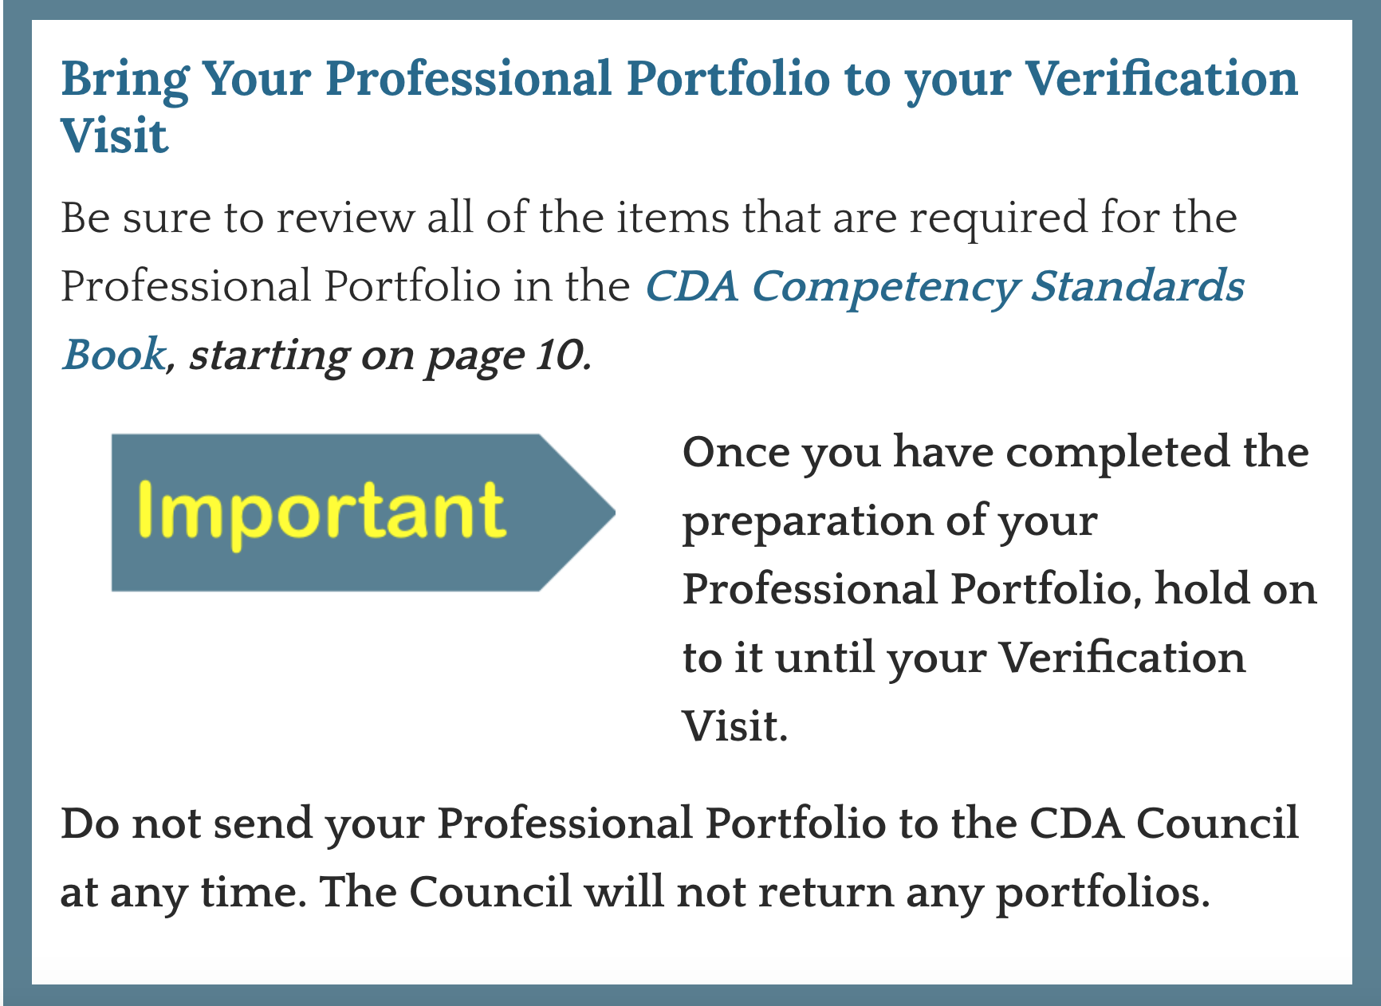

CDA Credential Process
The CDA credentialing program is administered by the CDA Council at the Council for Professional Recognition, a non-profit organization whose mission is to “promote improved performance and recognition of professionals in the early childhood education of children ages birth to 5 years old.”
Below are the steps to obtaining a CDA Credential.
Step 1
CDA applicant must complete 120 hours of training for professional early childhood education. Refer to pages 8-9 in the CDA Competency Standards Book.
Step 2
Up to 3 years prior to applying for the CDA Credential, you’d need to achieve at least 480 hours of professional experience working with the age group that matches the setting for which you are applying for the Credential. Refer to page 10 in the CDA Competency Standards Book.
Step 3
The Professional Portfolio is compiled independently by each Candidate as part of the CDA credentialing process. The compiled resources and documents are reviewed by the CDA PD Specialist during the CDA Verification Visit. Refer to the CDA Competency Standards Book starting on page 10.

- Have you finished the 120 hours of training?
- Do you have 480 hours of work experience?
- Is your Professional Portfolio Complete?
If the answer to these three questions is YES, then you are ready to apply.

Step 4: Apply for the Credential
Refer to pages 19-22 in the CDA Competency Standards Book.
- Apply online for your CDA Credential using the YourCDA online application system or complete a paper application provided in the CDA Competency Standards Book.
- The non-refundable/non-transferable application fee of $425 must be submitted with your application. Learn about CDA scholarships in your state.
- Once your CDA application has been reviewed and accepted you will receive a Ready to Schedule notification from the Council.
Weblinks for resources:
YourCDA Online application system: https://www.cdacouncil.org/yourcouncil-for-cda-candidates
CDA Competency Standards Book: http://store.cdacouncil.org/cdaapplicationpackets.aspx
CDA scholarships in your state: https://www.cdacouncil.org/resources/find-cda-scholarships
Step 5
Once you receive your Ready to Schedule notification from the CDA Council, you are ready to schedule your CDA Verification Visit and CDA Exam. Next, you’ll need to find a CDA Professional Development Specialist to do your Verification Visit. Use the Council’s directory to find a PD Specialist near you. Refer to the CDA Competency Standards Book starting on page 22/23 and pages 26-29.

Remember to renew!
Once you receive your CDA Credential, you will need to renew it every three years.

